Git:
It is a distributed version control system where each participant has a copy which is available at the remote location (Git Repository) so that we have the ability to manage the version hence git is called as version control tool or Continuous integration tool.

We have multiple platforms available to perform the actions:
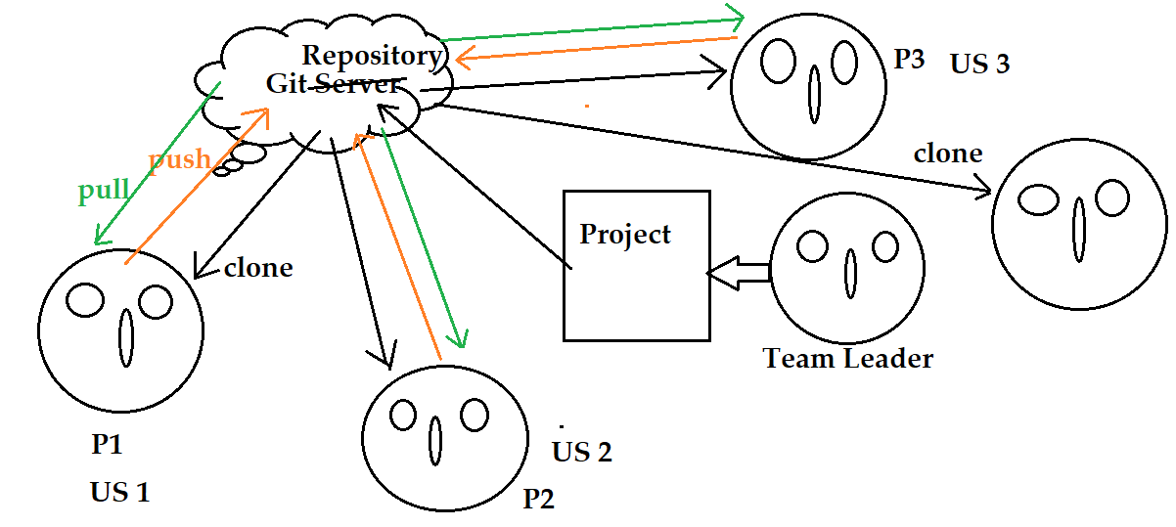
Example: GitHub, GitLab, Bit bucket etc
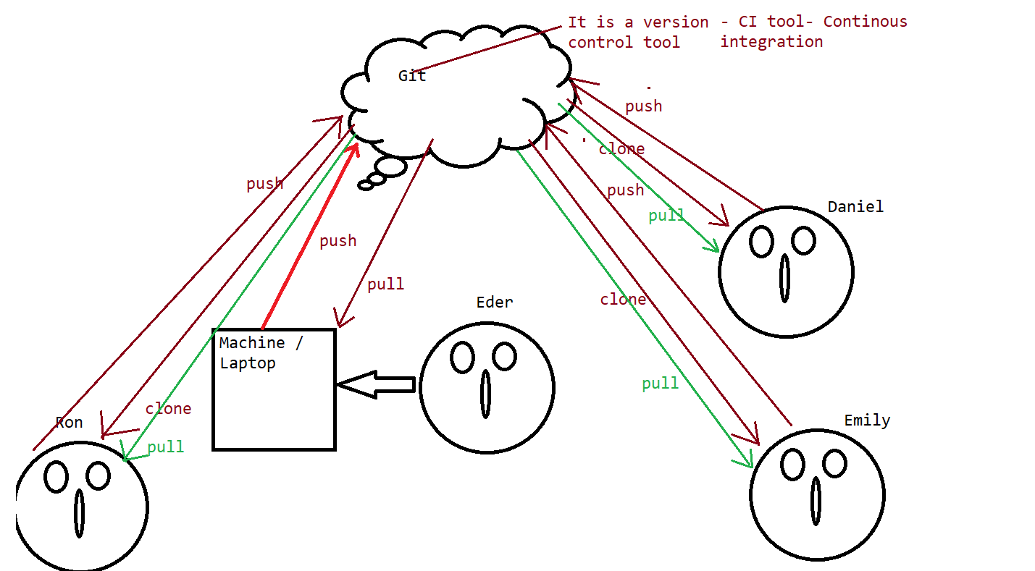

Git workflow

To download git:
https://git-scm.com/downloads
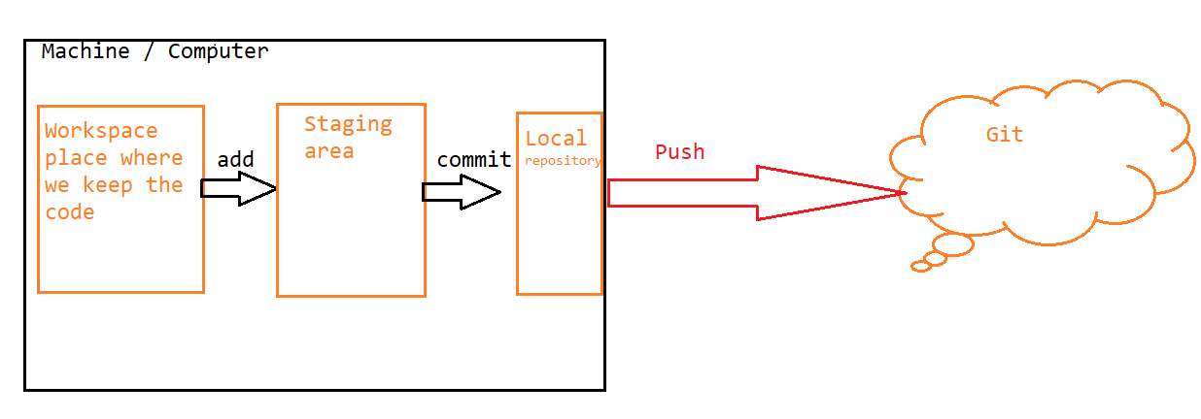
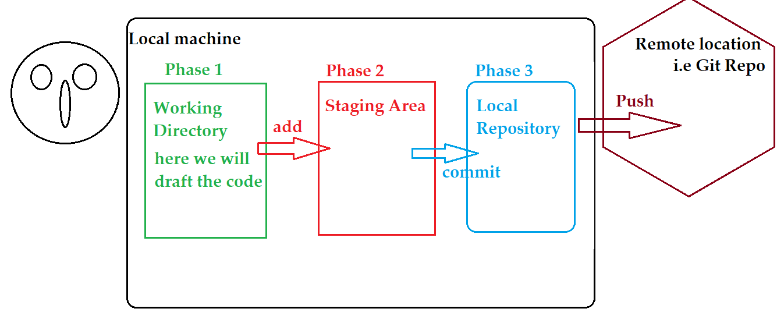
Download git:
https://git-scm.com/downloads
Command to check the version: git - -version
Git commands:
1. git init: This command is used to initialize the empty repository that means we are able to perform the other git operations on that folder.
2. git config - - global user.name “anyusername”: This command is used to set a username which will be set as a commit identifier.
3. git config - - global user.email “gourav@g.com” : This command is used to set the email address inside the system just to perform the git operations.
4. git config - - list: This command is used to check the configured value.
5. git add . : This command is used to move all files into the staging area so that we can perform the commit operation.
6. git commit –m “commit message”: This command is used to move the code to the local repository.
7. git status: This command is used to check the status of the files about their stages i.e if they are at staging area or local repository.
8. git remote add origin <repository_url> : This command is used to add the remote repository url to the system so that it can push the changes to the desired location.
9. git remote –v: This command is used to check the set url for the repository.
10. git push origin master: This command is used to push the changes to the remote repository from the local repository.
Note:
If we are performing the process for the first time then we need to authenticate ourselves by providing the personal access token / login using the popup.
11. git log - -online : This command is used to check the logs of the commit we have made.

Branching: It is the process in which we take the mirror image of the base code and called as a branch.
This is majorly used to track the individual changes done by the user for their feature.
12. git branch: This command is used to check the current branch on which we are available.
13. git pull origin master: This command is used to get the code added to the working directory from remote repository of the git.

14. git clone <repo url>: This command is used to get the copy of the code from github to the local machine folder.

